Progress Report June 2021 - A.P.S.U.

## June 15th Meeting

Final assembly design with measured lengths fit to material supply. Considerations for all possible design choices given our limitations have been completed. Final CAD representation also completed for panel assembly.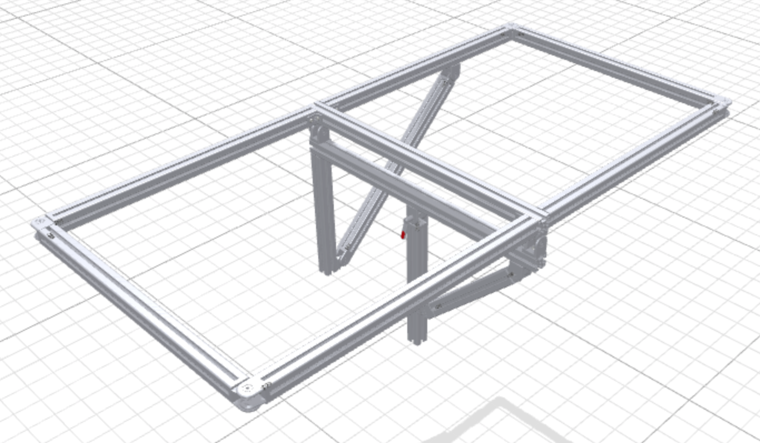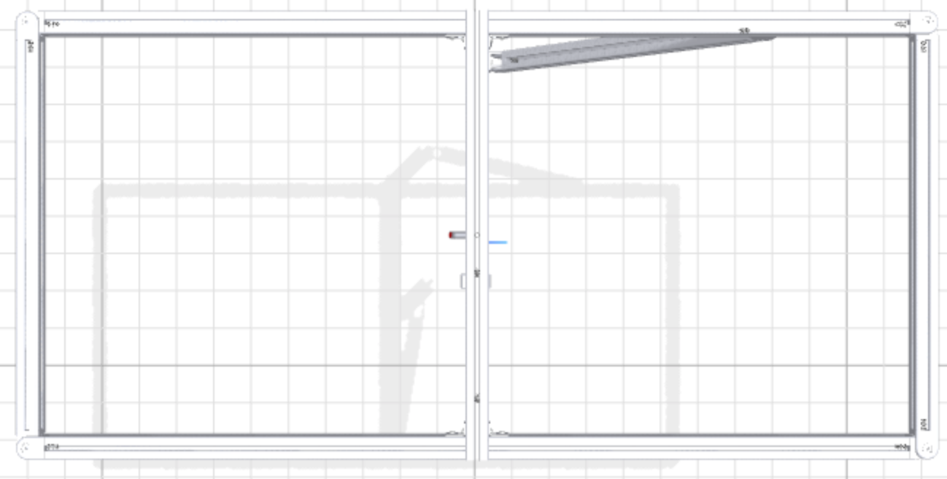

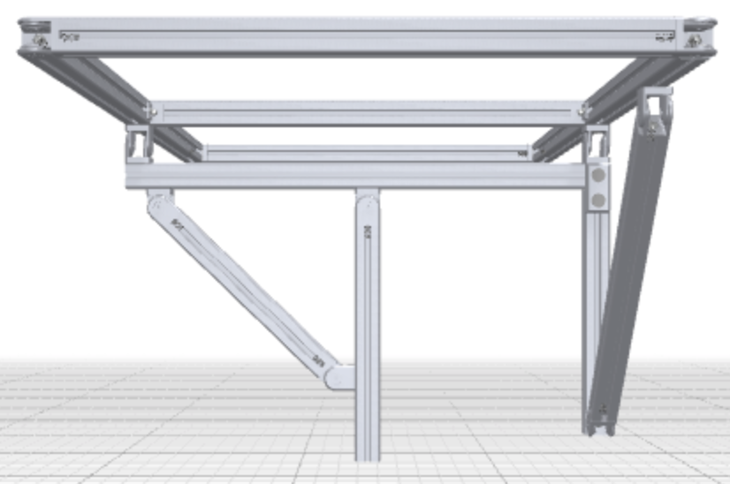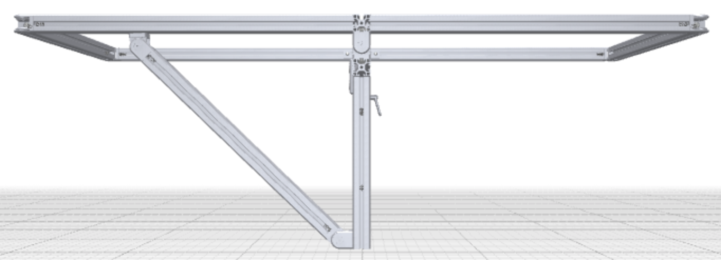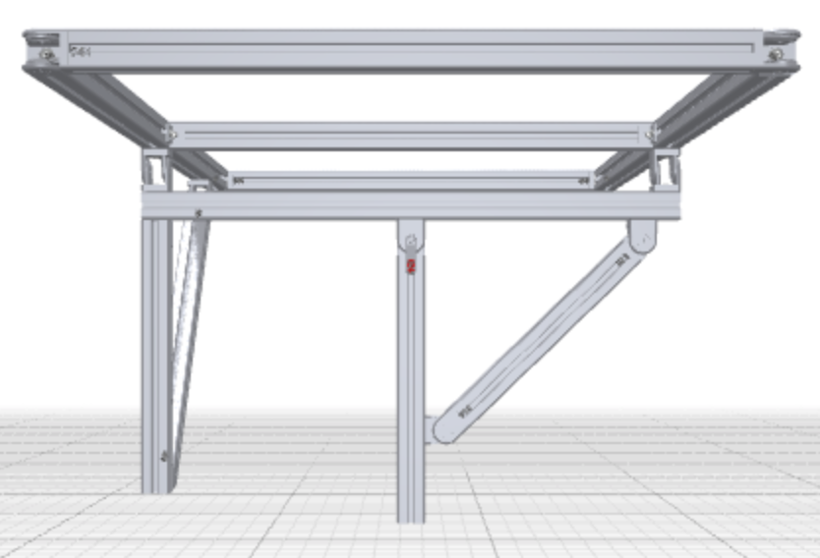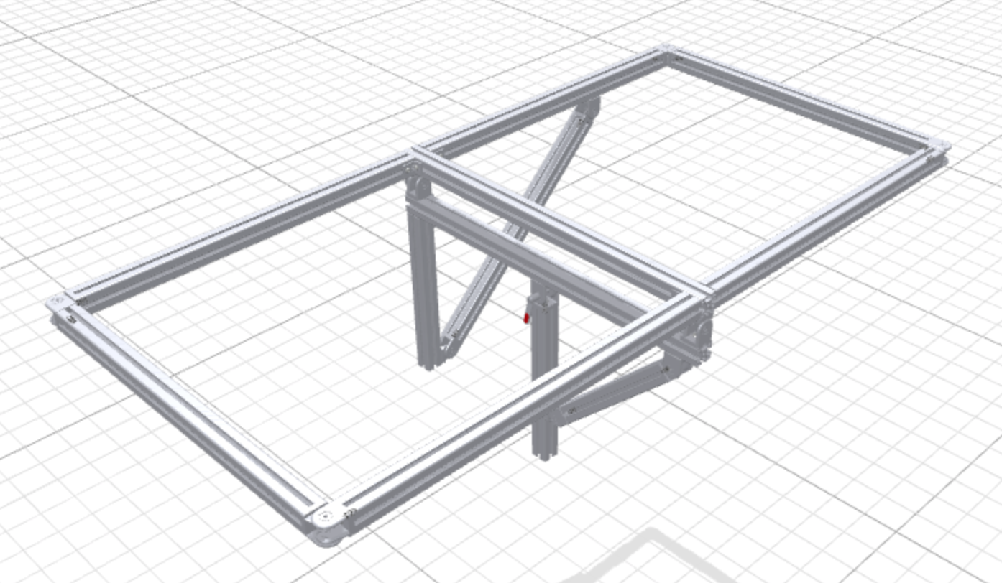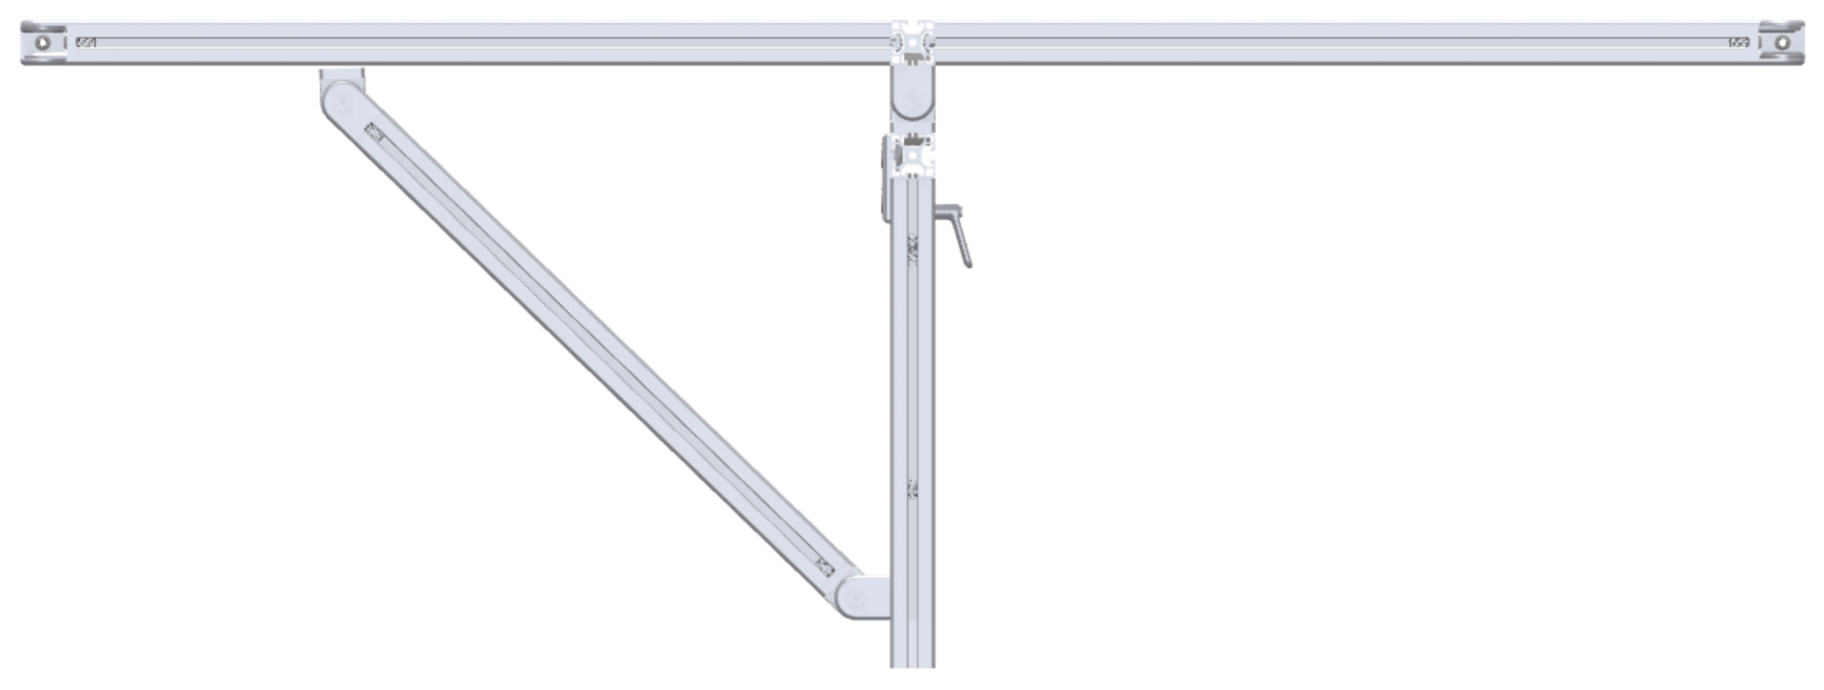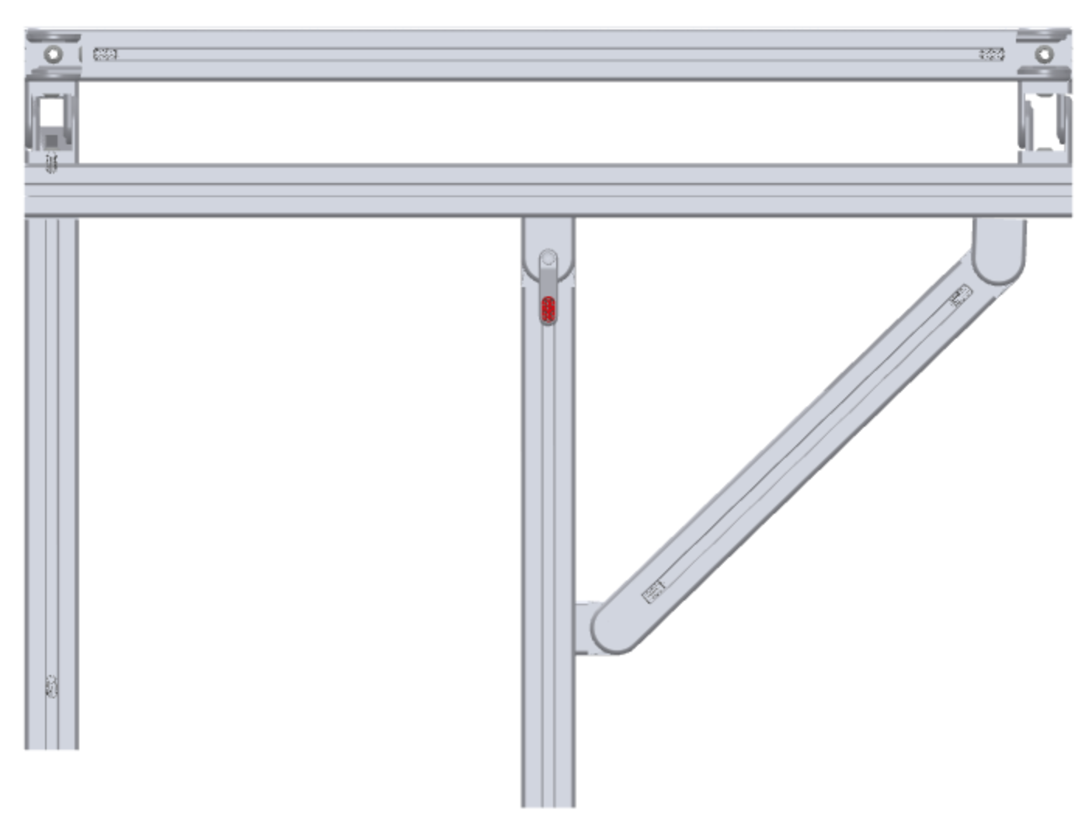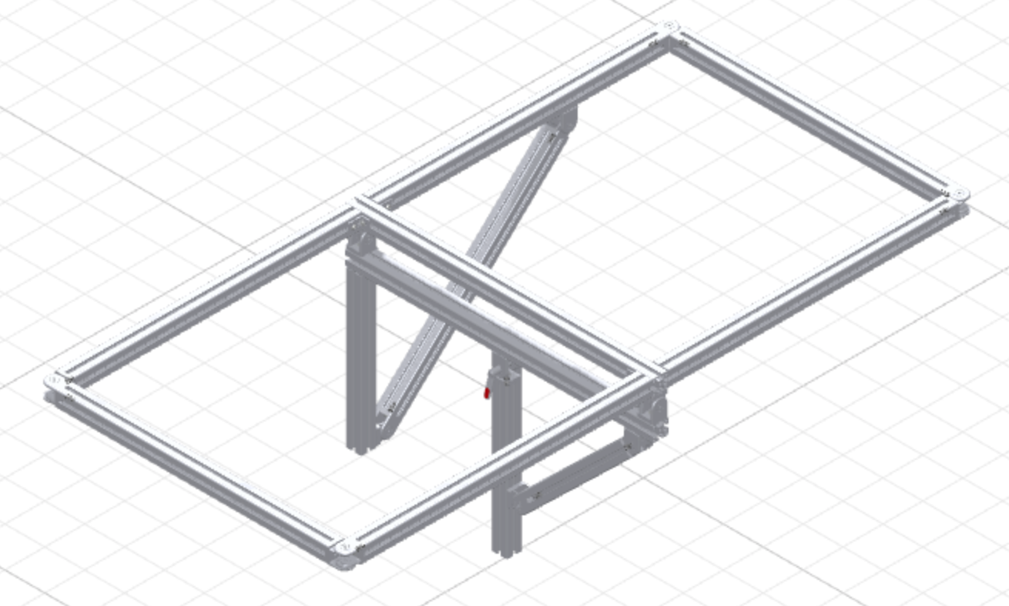

## Post - 16in

## Double Bar - 26in each

## Long Actuator Bar - 16in

## **Framing Total - 84in**

## Base Legs - 26in each

## Base Strut - 44in

## **Base Total - 96in**

## Total Framing 180in.

## 12 in. extra extrusions.

Long Side (East + West)

Short Side (North + South)

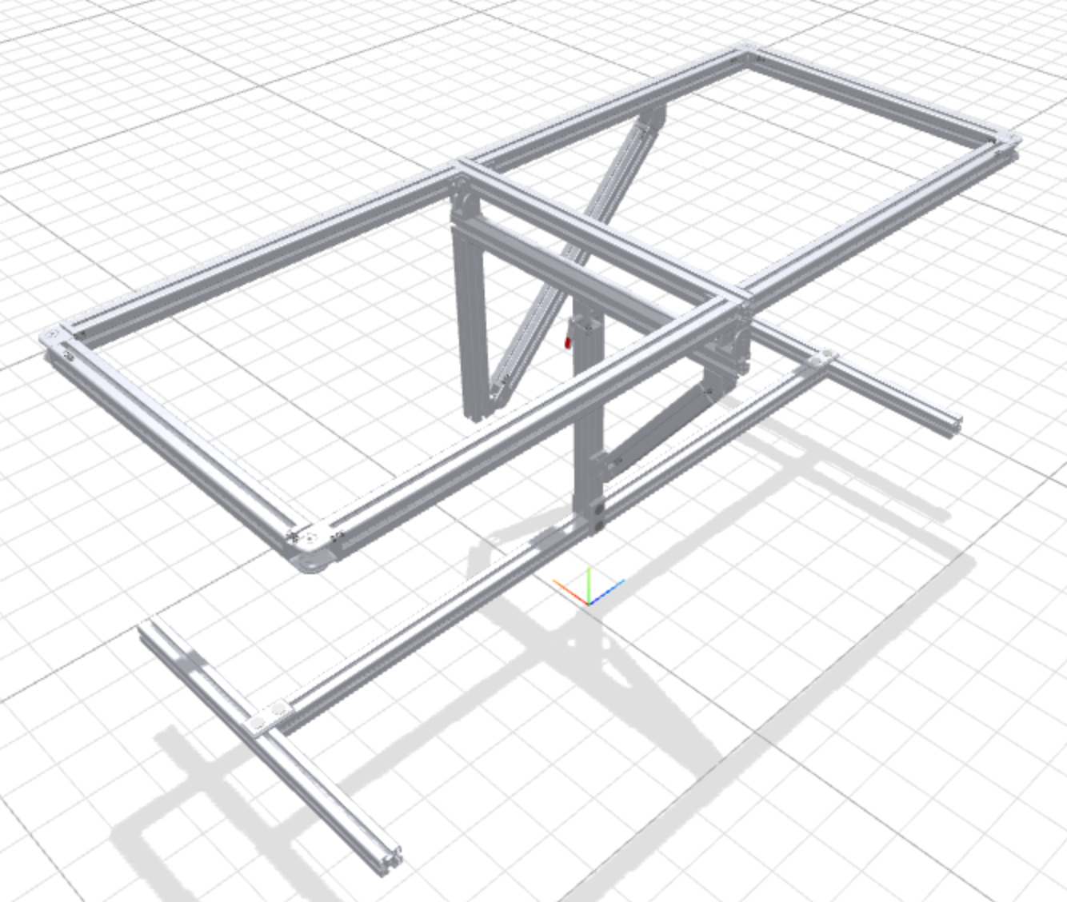

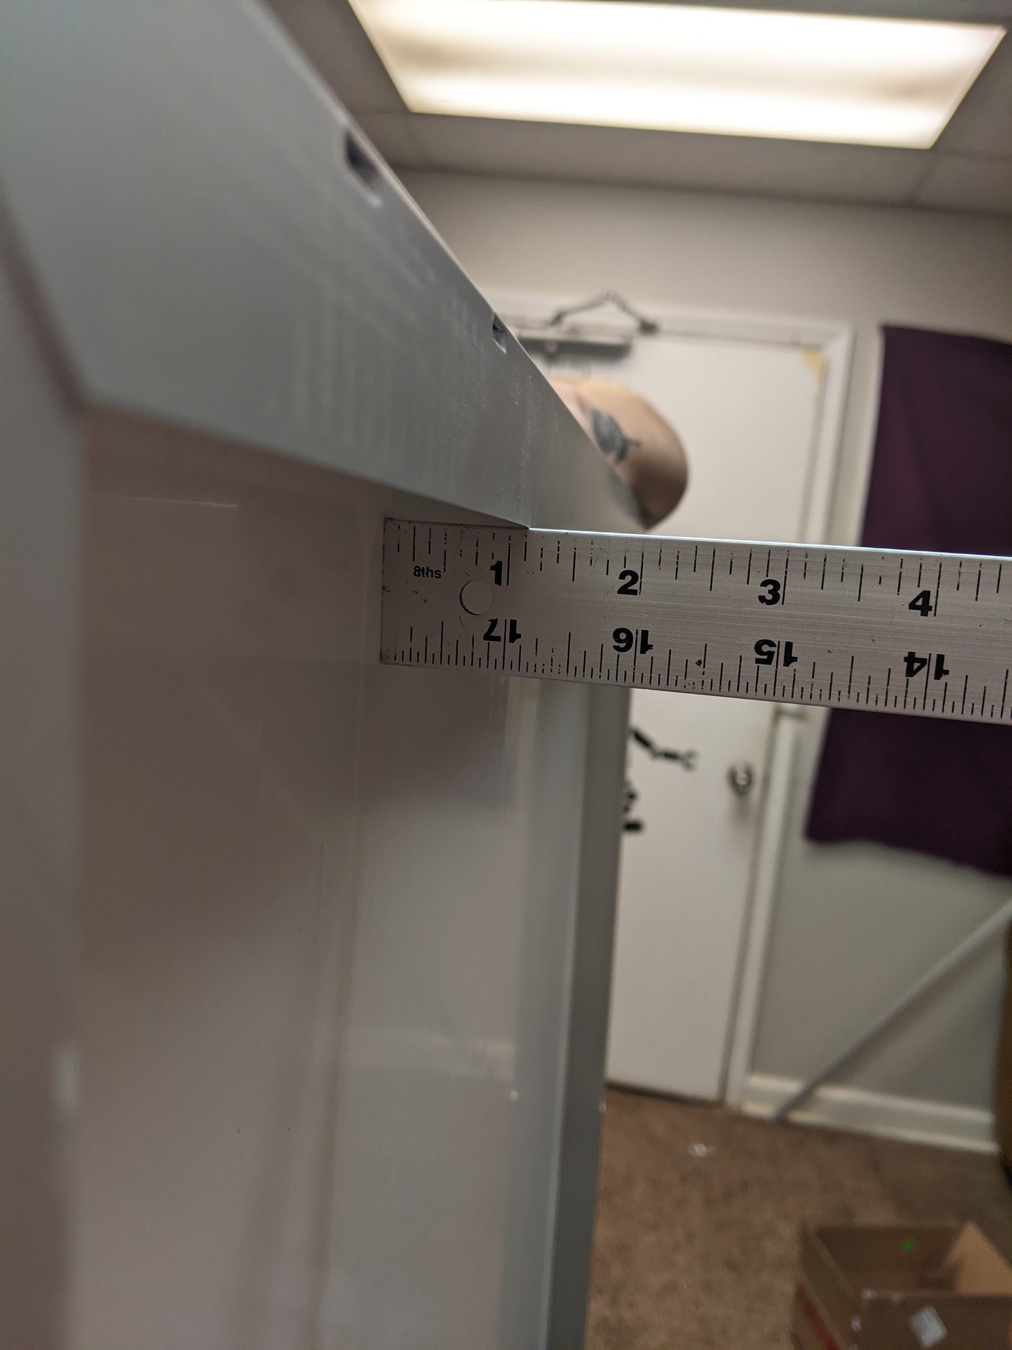

26 ⅜ in. outer width measured

58 ¼ in. outer length measured

26.2 in. width on website

58.3 in. length on website

0 1/16 in. thick material

1 1/16 in. panel to plate depth

1in. X 1in. Extrusion

# What Is Next

## June 23rd

Cut aluminum extrusions to lengths and assemble the physical structure.

Test electronic power consumption from panel to battery and to USB device.

## June 30th

Install electronic systems and panels to begin testing of system functions with manual control from microcontroller.

Decide on branding and illumination methods.

## July 7th

Program enhancements and cycle corrections need to be worked on for the system.

## July 14th

Final product should be operational with continuous tweaking and small upgrading to make the product stand out until the due date.